Transfer credit may be inadvertently locked in a student’s academic record. When a transfer credit is locked, it cannot be edited. In this case, you may need to manually unlock the transfer credit, thereby making the credit eligible for editing.

Use this guide to unlock transfer credit.

Instructions
- Locate the student’s academic record and click “Academics”.
- Locate and click the “External Records” tab.
- Locate the transcript with the locked credit. In the Transcript column, click related actions .
- Click “Student External Transcript”.
- Click “Student Transfer Credit Troubleshooting Console”.

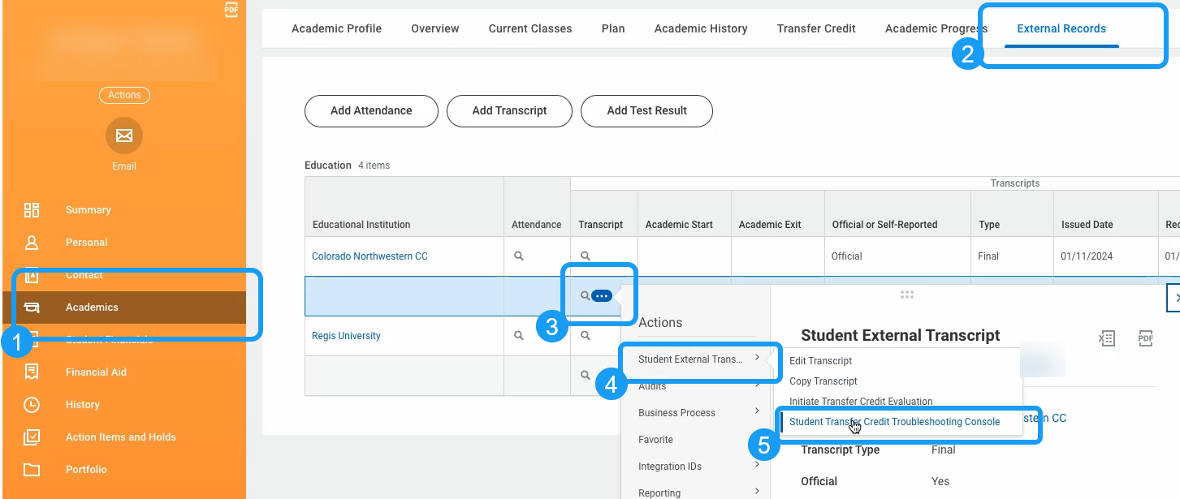

- The Student Transfer Credit Troubleshooting Console page will open and will display the Assigned Transfer Credit table. Locate the Locked Credit column and identify the individual credit(s) marked as “Yes”.

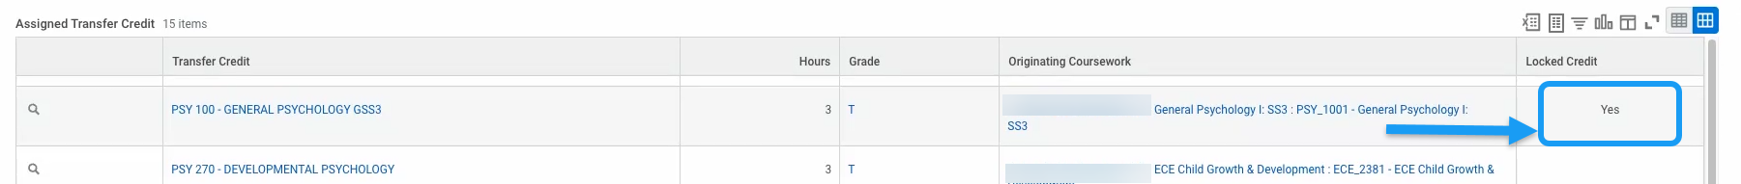

- To unlock, click the related actions for the credit .
- Click “Transfer Credit Registration”.
- Click “Edit”.

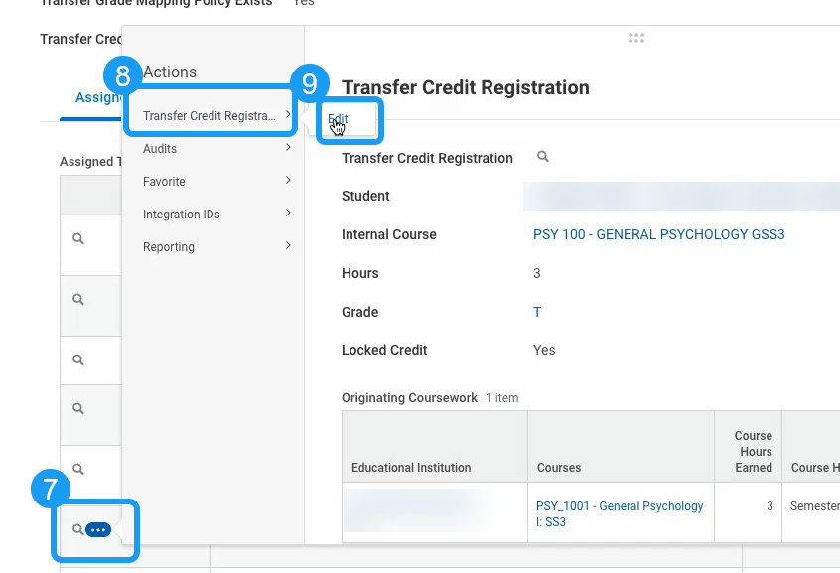

- The Edit Student Transfer Credit window will appear. Locate the Lock Credit checkbox. To unlock the credit, uncheck the box.

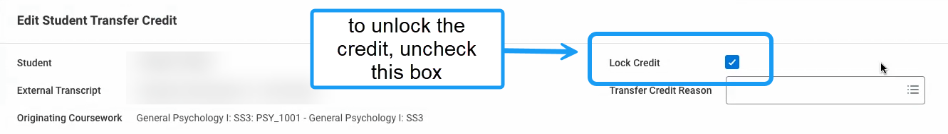

- Click “OK”.
- Click “Done”.

For more information about using the Transfer Troubleshooting Console, review this article in Workday Community: https://doc.workday.com/admin-guide/en-us/student/student-records/academic-records/t[…]it-evaluation/transfer-credit-evaluation-troubleshooting.html

